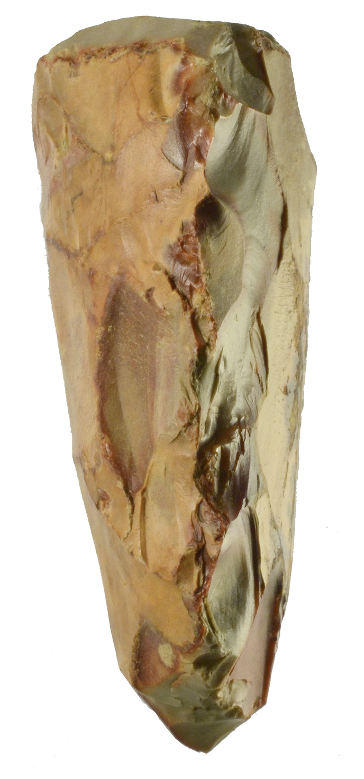

The Path of Many Arrows
An Odyssey Past Stillness and Singularity
(Reimagining Civilization in the Age of AI)

Carbon, Silicon
&
Sam Seatt

“We cannot solve our problems with the same thinking we used when we created them.”
— Albert Einstein

Published 2026
First Edition

Guten Ink

